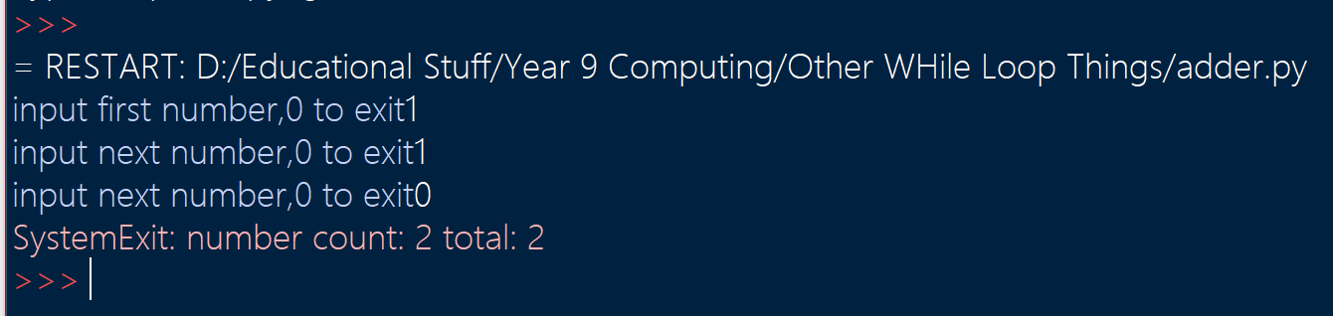
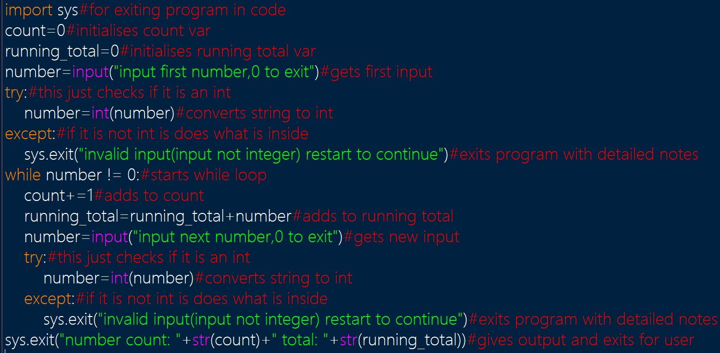
Mert Adder 27/4/2021

